Creating a Project from a Remote Repository with STS

Note: GIT Repository has allredy present in STS, just you want to configure ,if you are using eclipse you needed to installed GIT plugine form market place.
https://crunchify.com/how-to-configure-bitbucket-git-repository-in-you-eclipse/
https://docs.joomla.org/Working_with_Git_and_Eclipse

Step 1: Select Repository Source
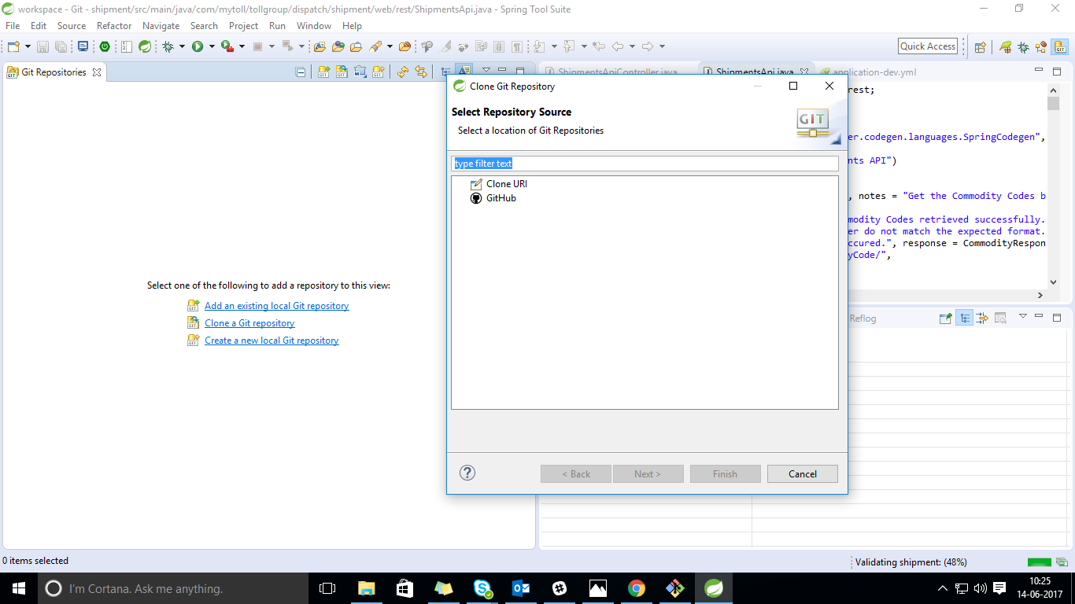
Step 2: Select “Clone_URL” to Clone GIT Repository
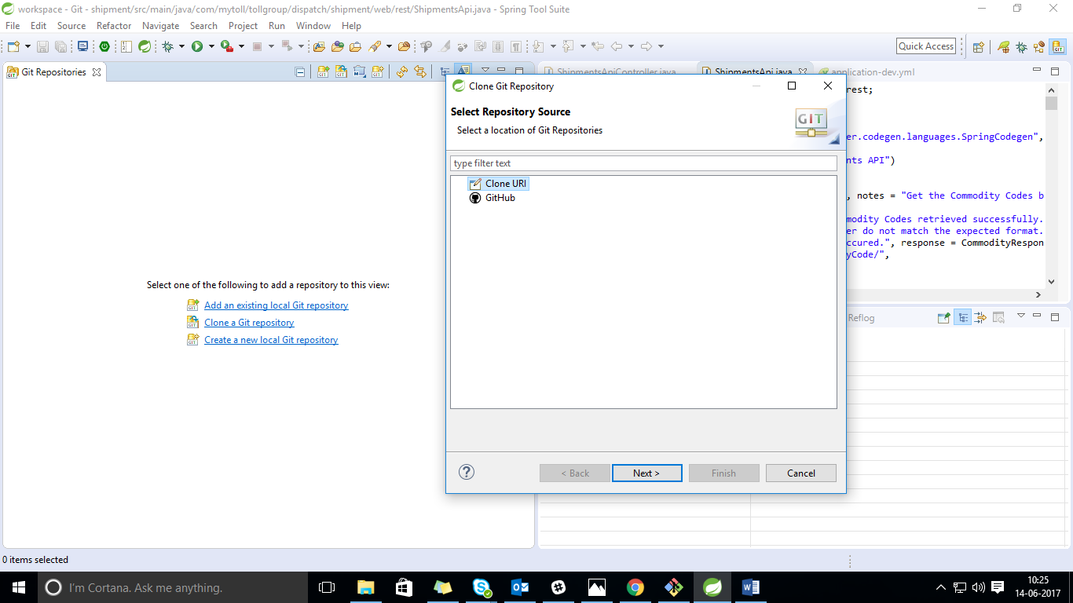

Step 3: Enter the location of the source repository
URL: GIT URL to your project
Username:
Password:
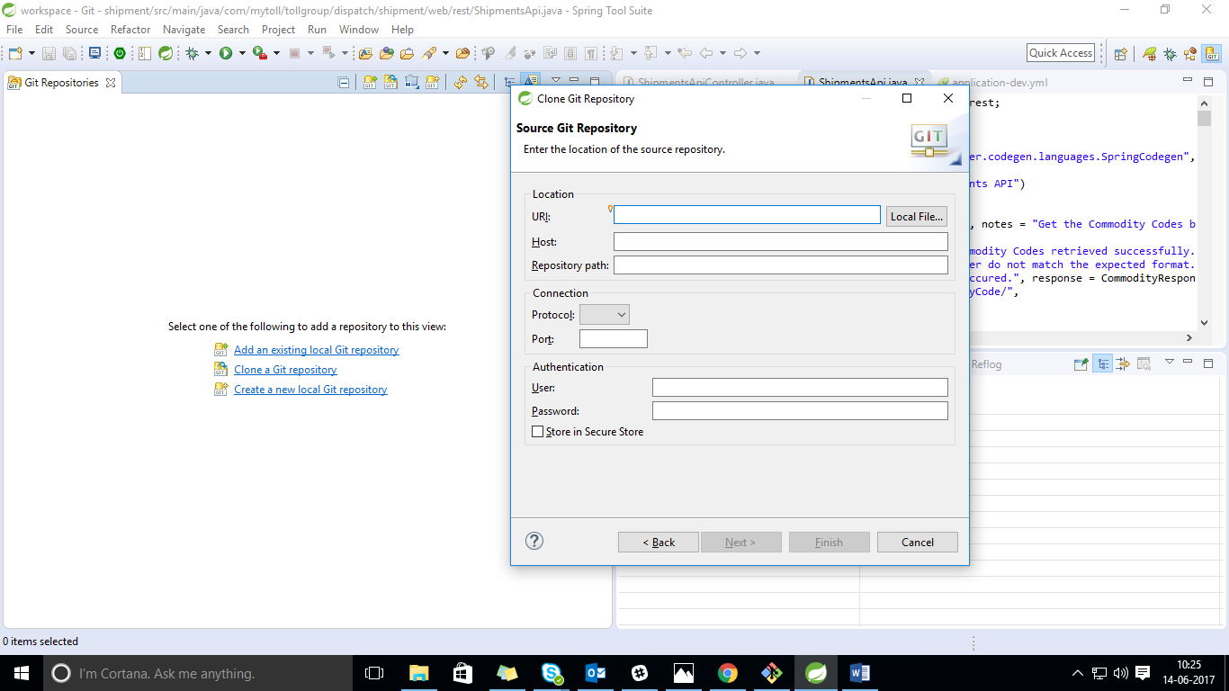

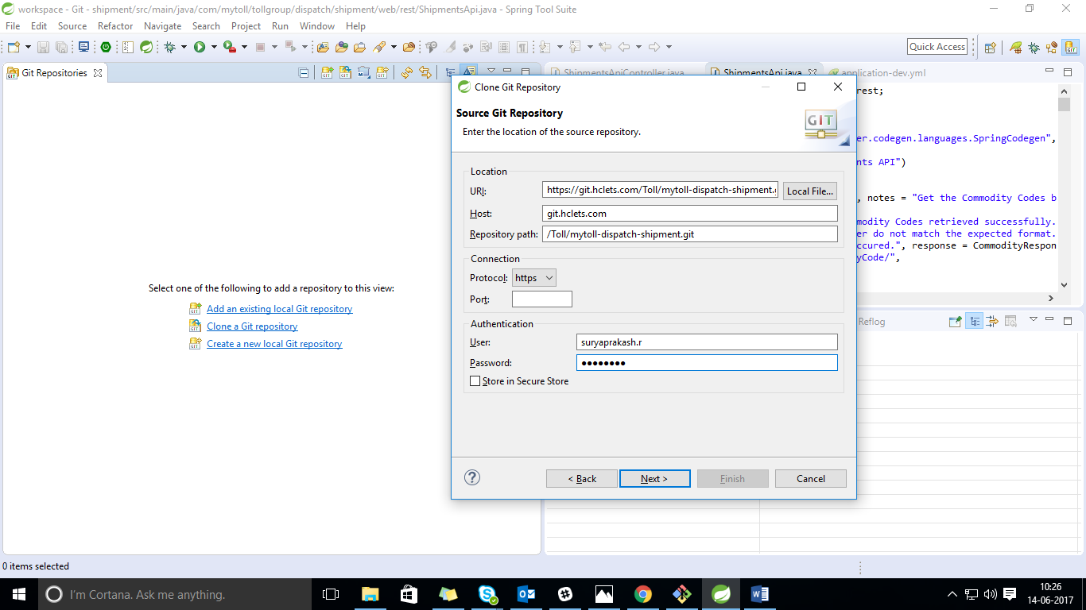

Step 4: Select to clone from remote repository like as <featureBrance1>
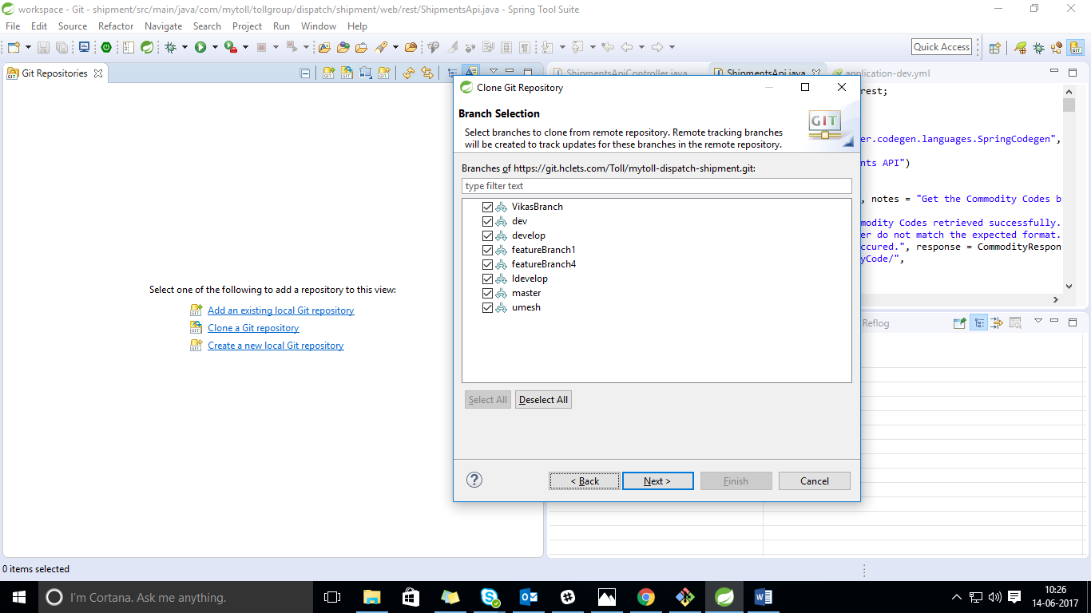
Step 5: Configure the local storage location for project into you STS workspace
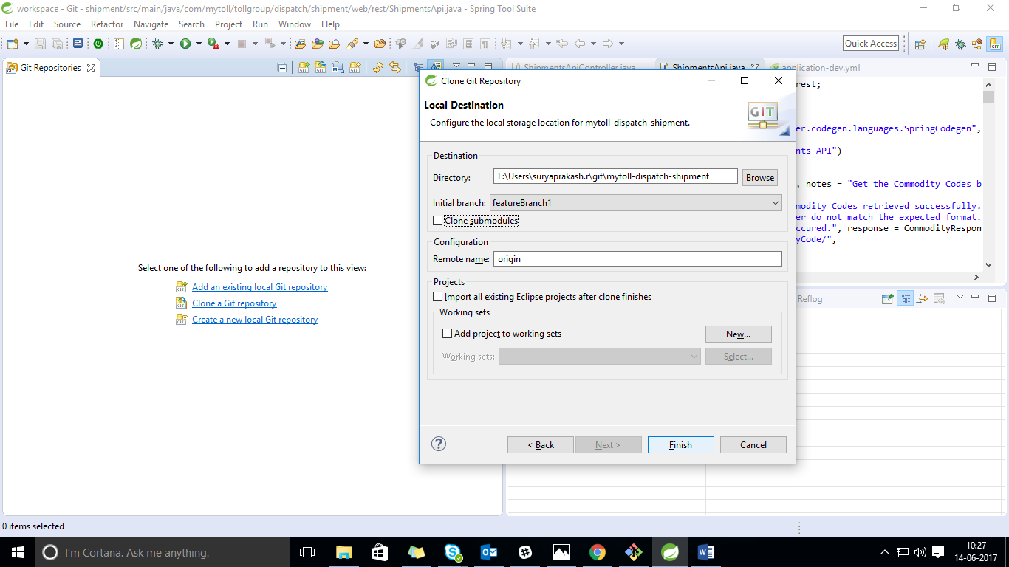
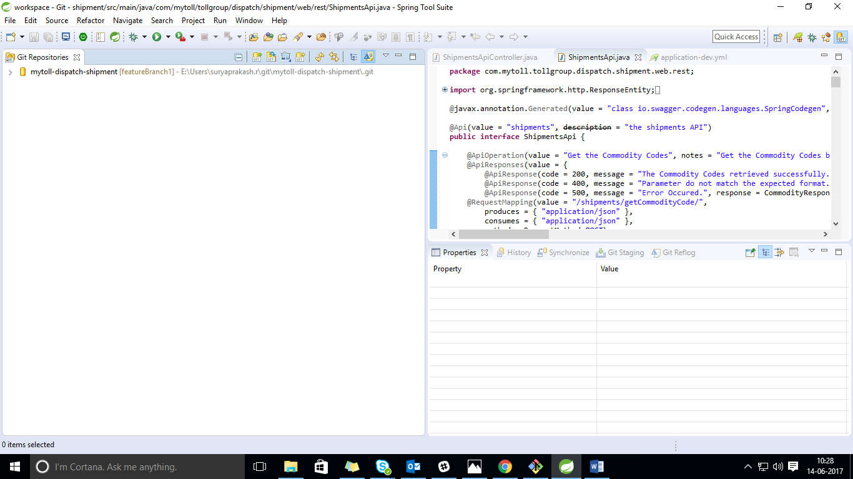
Step 6: check out the project “Shipment” into your local workspace.
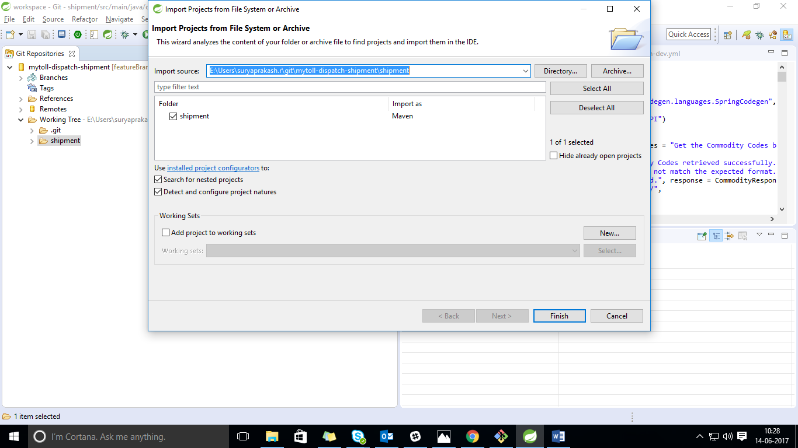

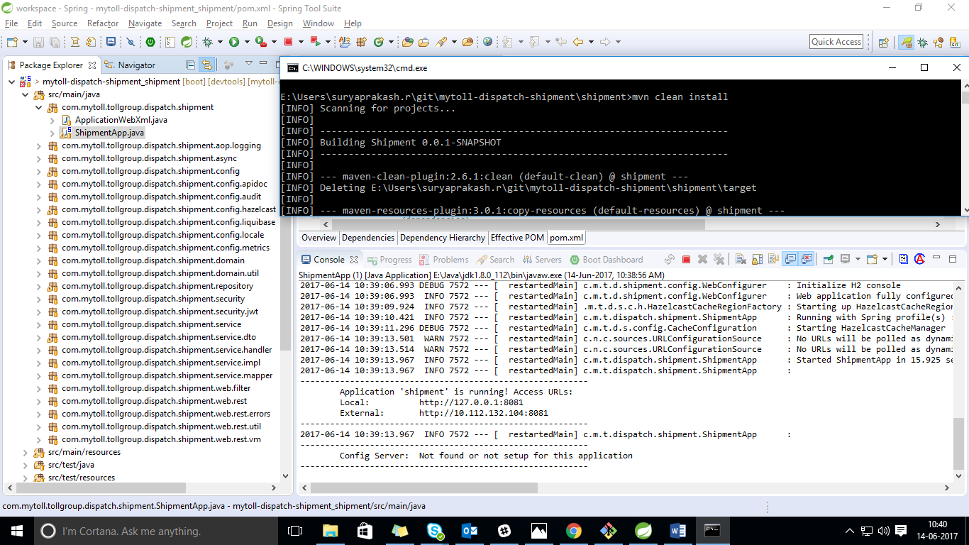

Check in and check out the code from GIT

Step 2: Synchronize the code with GIT first
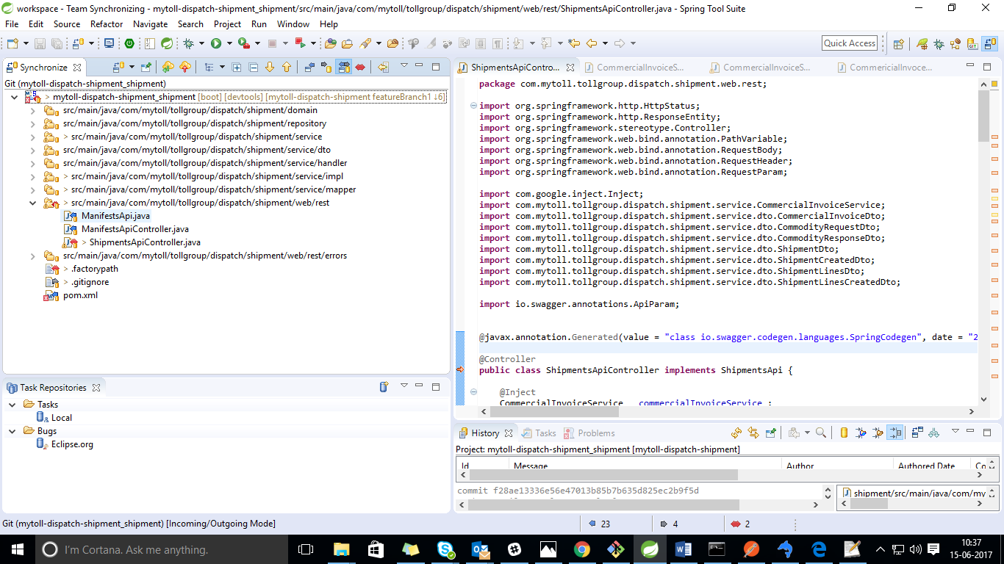
Click on conflict file and pull this code in our local environment.

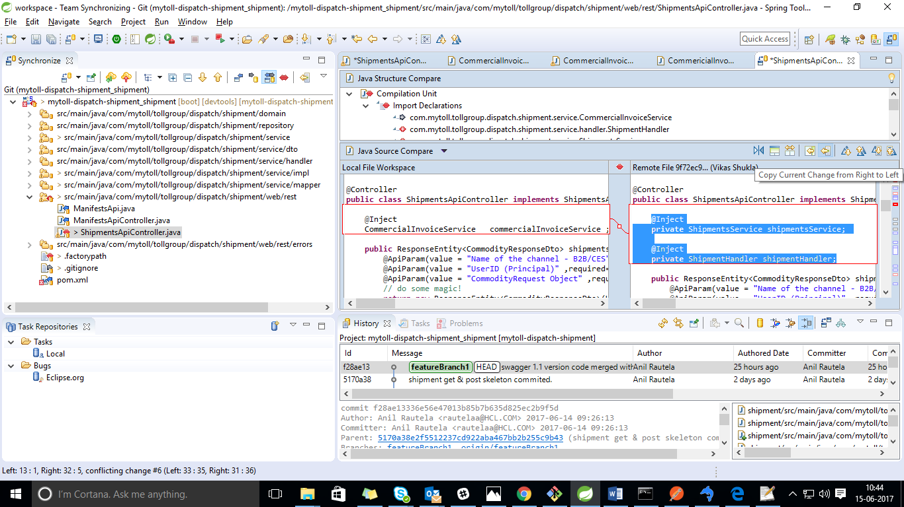

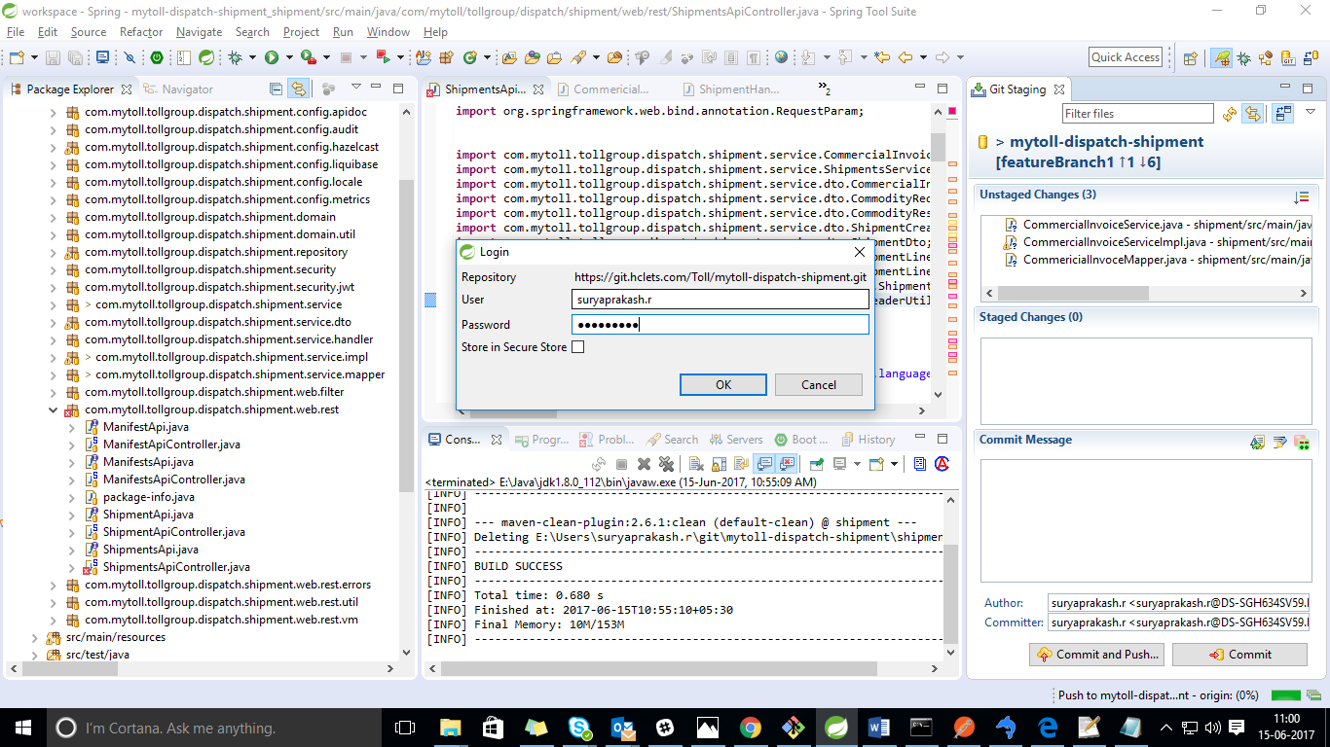
: Right click it and navigate to Team => Add.
after then Push the code
Before pushing the file add that new file on git using terminal
git add after then
git push origin branch
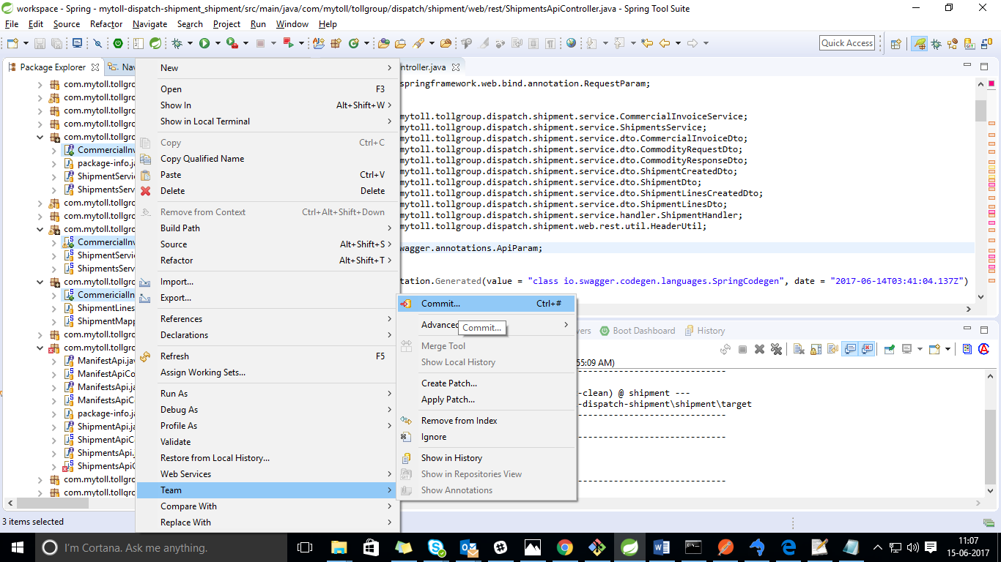
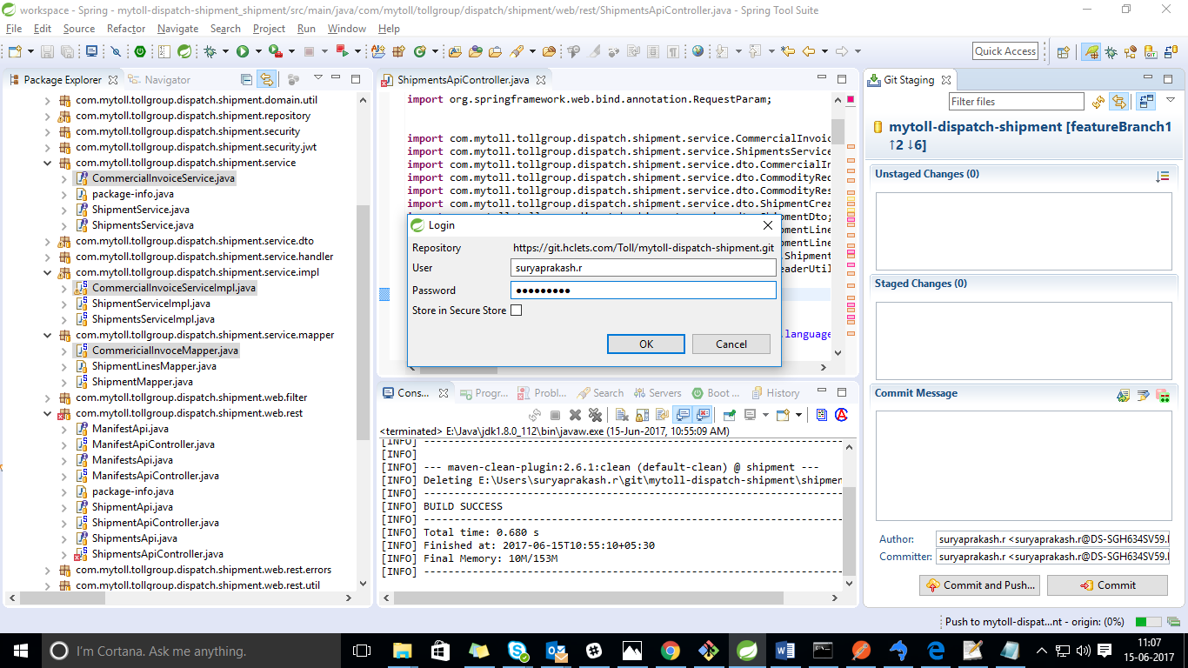
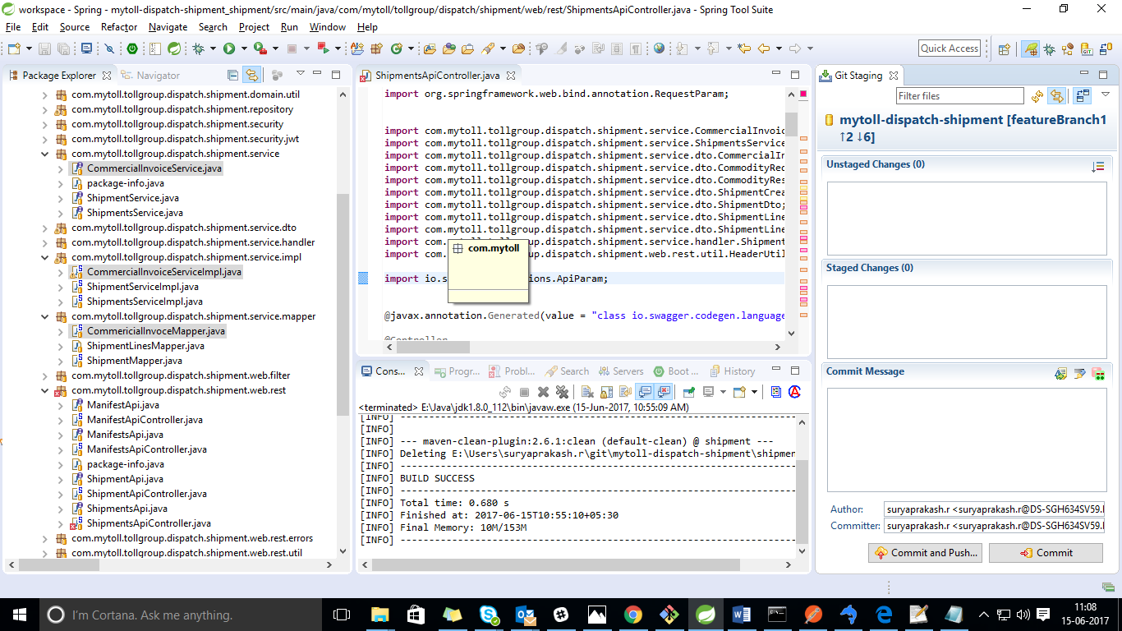

suryaprakash.r@DS-SGH634SV59 MINGW64 /e/sts-bundle/sts-3.8.3.RELEASE/workspace/m ytoll-dispatch-shipment (featureBranch1)
$ git status
On branch featureBranch1
Your branch is behind 'origin/featureBranch1' by 7 commits, and can be fast-forw arded.
(use "git pull" to update your local branch)
Changes not staged for commit:
(use "git add <file>..." to update what will be committed)
(use "git checkout -- <file>..." to discard changes in working directory)

modified: shipment/src/main/java/com/mytoll/tollgroup/dispatch/shipmen t/domain/CommercialInvoice.java
modified: shipment/src/main/java/com/mytoll/tollgroup/dispatch/shipmen t/domain/ShipmentLineItem.java
modified: shipment/src/main/java/com/mytoll/tollgroup/dispatch/shipmen t/web/rest/ShipmentsApiController.java

Untracked files:
(use "git add <file>..." to include in what will be committed)

shipment/src/main/java/com/mytoll/tollgroup/dispatch/shipment/service/Co mmercialInvoiceService.java
shipment/src/main/java/com/mytoll/tollgroup/dispatch/shipment/service/im pl/CommercialInvoiceServiceImpl.java
shipment/src/main/java/com/mytoll/tollgroup/dispatch/shipment/service/ma pper/CommericialInvoceMapper.java

no changes added to commit (use "git add" and/or "git commit -a")

suryaprakash.r@DS-SGH634SV59 MINGW64 /e/sts-bundle/sts-3.8.3.RELEASE/workspace/m ytoll-dispatch-shipment (featureBranch1)
$ git pull
fatal: Authentication failed for 'https://git.hclets.com/Toll/mytoll-dispatch-sh ipment.git/'

suryaprakash.r@DS-SGH634SV59 MINGW64 /e/sts-bundle/sts-3.8.3.RELEASE/workspace/m ytoll-dispatch-shipment (featureBranch1)
$ git config --global http.sslVerify false

suryaprakash.r@DS-SGH634SV59 MINGW64 /e/sts-bundle/sts-3.8.3.RELEASE/workspace/m ytoll-dispatch-shipment (featureBranch1)
$ git pull
remote: Counting objects: 42, done.
remote: Compressing objects: 100% (15/15), done.
remote: Total 21 (delta 10), reused 0 (delta 0)
Unpacking objects: 100% (21/21), done.
From https://git.hclets.com/Toll/mytoll-dispatch-shipment
969ce4b..7620bf9 featureBranch1 -> origin/featureBranch1
error: Your local changes to the following files would be overwritten by merge:
shipment/src/main/java/com/mytoll/tollgroup/dispatch/shipment/web/rest/S hipmentsApiController.java
Please commit your changes or stash them before you merge.
Aborting
Updating 32e22bb..7620bf9

suryaprakash.r@DS-SGH634SV59 MINGW64 /e/sts-bundle/sts-3.8.3.RELEASE/workspace/m ytoll-dispatch-shipment (featureBranch1)
$ git stash
Saved working directory and index state WIP on featureBranch1: 32e22bb shipment update code commited
HEAD is now at 32e22bb shipment update code commited

suryaprakash.r@DS-SGH634SV59 MINGW64 /e/sts-bundle/sts-3.8.3.RELEASE/workspace/m ytoll-dispatch-shipment (featureBranch1)
$ git pull
Updating 32e22bb..7620bf9
Fast-forward
.../repository/ShipmentLineRepository.java | 11 +-
.../shipment/repository/ShipmentRepository.java | 7 +-
.../dispatch/shipment/service/ShipmentService.java | 2 +-
.../shipment/service/ShipmentsService.java | 9 +-
.../shipment/service/dto/CustomSerializer.java | 5 +-
.../dispatch/shipment/service/dto/ShipmentDto.java | 32 +++---
.../shipment/service/dto/ShipmentPartiesDto.java | 42 ++++++++
.../shipment/service/handler/ShipmentHandler.java | 26 ++---
.../shipment/service/impl/ShipmentServiceImpl.java | 17 +--
.../service/impl/ShipmentsServiceImpl.java | 22 ++--
.../service/mapper/ShipmentLinesMapper.java | 113 ++++++++++---------
.../shipment/service/mapper/ShipmentMapper.java | 119 ++++++++++++++++-----
.../dispatch/shipment/web/rest/ShipmentsApi.java | 5 +-
.../shipment/web/rest/ShipmentsApiController.java | 41 ++++---
14 files changed, 308 insertions(+), 143 deletions(-)
create mode 100644 shipment/src/main/java/com/mytoll/tollgroup/dispatch/shipmen t/service/dto/ShipmentPartiesDto.java

suryaprakash.r@DS-SGH634SV59 MINGW64 /e/sts-bundle/sts-3.8.3.RELEASE/workspace/m ytoll-dispatch-shipment (featureBranch1)
$ git stash pop
Auto-merging shipment/src/main/java/com/mytoll/tollgroup/dispatch/shipment/web/r est/ShipmentsApiController.java
On branch featureBranch1
Your branch is up-to-date with 'origin/featureBranch1'.
Changes not staged for commit:
(use "git add <file>..." to update what will be committed)
(use "git checkout -- <file>..." to discard changes in working directory)

modified: shipment/src/main/java/com/mytoll/tollgroup/dispatch/shipmen t/domain/CommercialInvoice.java
modified: shipment/src/main/java/com/mytoll/tollgroup/dispatch/shipmen t/domain/ShipmentLineItem.java
modified: shipment/src/main/java/com/mytoll/tollgroup/dispatch/shipmen t/web/rest/ShipmentsApiController.java

Untracked files:
(use "git add <file>..." to include in what will be committed)

shipment/src/main/java/com/mytoll/tollgroup/dispatch/shipment/service/Co mmercialInvoiceService.java
shipment/src/main/java/com/mytoll/tollgroup/dispatch/shipment/service/im pl/CommercialInvoiceServiceImpl.java
shipment/src/main/java/com/mytoll/tollgroup/dispatch/shipment/service/ma pper/CommericialInvoceMapper.java

no changes added to commit (use "git add" and/or "git commit -a")
Dropped refs/stash@{0} (3edeee89be74388e199b7b316b73e9f081306caa)

suryaprakash.r@DS-SGH634SV59 MINGW64 /e/sts-bundle/sts-3.8.3.RELEASE/workspace/m ytoll-dispatch-shipment (featureBranch1)
$ git add .
warning: CRLF will be replaced by LF in shipment/src/main/java/com/mytoll/tollgr oup/dispatch/shipment/service/CommercialInvoiceService.java.
The file will have its original line endings in your working directory.
warning: CRLF will be replaced by LF in shipment/src/main/java/com/mytoll/tollgr oup/dispatch/shipment/service/impl/CommercialInvoiceServiceImpl.java.
The file will have its original line endings in your working directory.
warning: CRLF will be replaced by LF in shipment/src/main/java/com/mytoll/tollgr oup/dispatch/shipment/service/mapper/CommericialInvoceMapper.java.
The file will have its original line endings in your working directory.

suryaprakash.r@DS-SGH634SV59 MINGW64 /e/sts-bundle/sts-3.8.3.RELEASE/workspace/m ytoll-dispatch-shipment (featureBranch1)
$ git commit -am"CommercialInvoice"
[featureBranch1 db87f2b] CommercialInvoice
Committer: Suryaprakash Rhuwanshi <suryaprakash.r@hcl.com>
Your name and email address were configured automatically based
on your username and hostname. Please check that they are accurate.
You can suppress this message by setting them explicitly:

git config --global user.name "Your Name"
git config --global user.email you@example.com

After doing this, you may fix the identity used for this commit with:

git commit --amend --reset-author

6 files changed, 183 insertions(+), 20 deletions(-)
create mode 100644 shipment/src/main/java/com/mytoll/tollgroup/dispatch/shipmen t/service/CommercialInvoiceService.java
create mode 100644 shipment/src/main/java/com/mytoll/tollgroup/dispatch/shipmen t/service/impl/CommercialInvoiceServiceImpl.java
create mode 100644 shipment/src/main/java/com/mytoll/tollgroup/dispatch/shipmen t/service/mapper/CommericialInvoceMapper.java

suryaprakash.r@DS-SGH634SV59 MINGW64 /e/sts-bundle/sts-3.8.3.RELEASE/workspace/m ytoll-dispatch-shipment (featureBranch1)
$ git push
Counting objects: 23, done.
Delta compression using up to 4 threads.
Compressing objects: 100% (17/17), done.
Writing objects: 100% (23/23), 3.13 KiB | 0 bytes/s, done.
Total 23 (delta 12), reused 0 (delta 0)
To https://git.hclets.com/Toll/mytoll-dispatch-shipment.git
7620bf9..db87f2b featureBranch1 -> featureBranch1

suryaprakash.r@DS-SGH634SV59 MINGW64 /e/sts-bundle/sts-3.8.3.RELEASE/workspace/m ytoll-dispatch-shipment (featureBranch1)
$

